Name: Priyanshu Tripathi
Roll number: 12022005

Subject: Java Programming
Code: CSPC-23
Assignment 1
INDEX
S. No. | Content | Page No.
1. | Count the number of letters in a string | 3
2. | Check if a string is a valid password | 4
3. | Find the largest common prefix between two strings | 5
4. | Check if the inputted SSN is valid | 6
5. | Check if the 2nd string is a substring of the 1st string | 7
6. | Check if an array has four consecutive equal numbers | 8
7. | Remove duplicates from an array | 10
8. | Check if two arrays are identical | 11

1. Count the number of letters in a string
Write a method that counts the number of letters in a string using the following header:
public static int countLetters(String s)
Write a test program that prompts the user to enter a string and displays the number of letters in the string.
import java.util.Scanner;

public class foobar {

public static void main(String[] args) {
Scanner scanner = new Scanner(System.in);

System.out.print("Enter the string --> ");
String string = scanner.nextLine();

System.out.println("\nNumber of letters in the string --> " + countLetters(string));
}

public static int countLetters(String s) {
int count = 0;
for (int i=0; i<s.length(); i++)
if (Character.isLetter(s.charAt(i)))
count++;
return count;
}
}
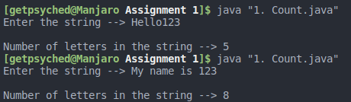

2. Check if a string is a valid password
Some websites impose certain rules for passwords. Write a method that checks whether a string is a valid password. Suppose the password rules are as follows:
■ A password must have at least eight characters.
■ A password consists of only letters and digits.
■ A password must contain at least two digits.
Write a program that prompts the user to enter a password and displays Valid Password if the rules are followed or Invalid Password otherwise.
import java.util.Scanner;

public class foobar {

public static void main(String[] args) {
Scanner scanner = new Scanner(System.in);

System.out.print("Enter the password --> ");
String string = scanner.nextLine();

if (validatePassword(string))
System.out.println("Valid Password");
else
System.out.println("Invalid Password");
}

public static boolean validatePassword(String s) {
int len = s.length();
if (len < 8)
return false;

int digits = 0;
for (int i=0; i<len; i++) {
if (!Character.isLetterOrDigit(s.charAt(i)))
return false;
if (Character.isDigit(s.charAt(i)))
digits++;
}

if (digits < 2)
return false;

return true;
}
}
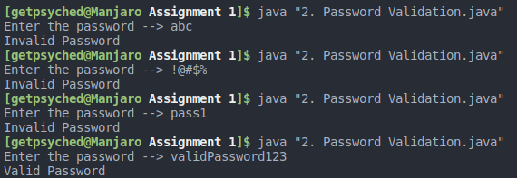

3. Find the largest common prefix between two strings
Write a program that prompts the user to enter two strings and displays the largest common prefix of the two strings. Here are some sample runs:
Enter the first string: Welcome to C++
Enter the second string: Welcome to programming
The common prefix is Welcome to
Enter the first string: Atlanta
Enter the second string: Macon
Atlanta and Macon have no common prefix
import java.util.Scanner;

public class foobar {

public static void main(String[] args) {
Scanner scanner = new Scanner(System.in);

System.out.print("Enter first string --> ");
String string1 = scanner.nextLine();

System.out.print("Enter second string --> ");
String string2 = scanner.nextLine();

String prefix = checkPrefix(string1, string2);

if (!prefix.isEmpty())
System.out.println("\nThe common prefix is " + prefix);
else
System.out.println(String.format("\n%s and %s have no common prefix", string1, string2));
}

public static String checkPrefix(String s1, String s2) {
int len1 = s1.length();
int len2 = s2.length();

String prefix = "";

for (int i=0; i < len1 && i < len2; i++)
if (s1.charAt(i) == s2.charAt(i))
prefix += s1.charAt(i);
else
return prefix;

return prefix;
}
}
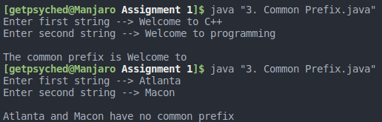

4. Check if the inputted SSN is valid
Write a program that prompts the user to enter a Social Security Number in the format DDD-DD-DDDD, where D is a digit. Your program should check whether the input is valid. Here are some sample runs:
Enter a SSN: 232-23-5435
232-23-5435 is a valid social security number
Enter a SSN: 23-23-5435
23-23-5435 is an invalid social security number
import java.util.Scanner;

public class foobar {

public static void main(String[] args) {
Scanner scanner = new Scanner(System.in);

System.out.print("Enter a SSN --> ");
String ssn = scanner.nextLine();

if (validateNumber(ssn))
System.out.println(ssn + " is a valid SSN");
else
System.out.println(ssn + " is an invalid SSN");
}

public static boolean validateNumber(String s) {
if (s.length() < 11)
return false;

try {
Integer.parseInt(s.substring(0, 3));
Integer.parseInt(s.substring(4, 6));
Integer.parseInt(s.substring(7, 11));
} catch (NumberFormatException e) {
return false;
}

if (s.charAt(3) != '-' || s.charAt(6) != '-')
return false;

return true;
}
}
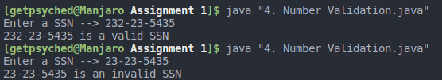

5. Check if the 2nd string is a substring of the 1st string
Write a program that prompts the user to enter two strings and reports whether the second string is a substring of the first string. Here are some sample runs:
Enter string s1: ABCD
Enter string s2: BC
BC is a substring of ABCD
Enter string s1: ABCD
Enter string s2: BDC
BDC is not a substring of ABCD
import java.util.Scanner;

public class foobar {

public static void main(String[] args) {
Scanner scanner = new Scanner(System.in);

System.out.print("Enter first string --> ");
String string1 = scanner.nextLine();

System.out.print("Enter second string --> ");
String string2 = scanner.nextLine();

if (checkSubstring(string1, string2))
System.out.println(String.format("\n%s is a substring of %s", string2, string1));
else
System.out.println(String.format("\n%s is not a substring of %s", string2, string1));
}

public static boolean checkSubstring(String s1, String s2) {
int len1 = s1.length();
int len2 = s2.length();

if (len2 > len1)
return false;

int i, j;
for (i=0; i < len1-len2; i++)
for (j=0; j < len2; j++)
if (s1.charAt(i+j) != s2.charAt(j))
break;
else if (j == len2 - 1)
return true;

return false;
}
}
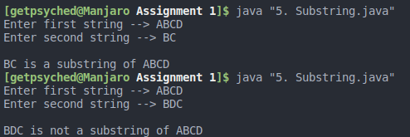

6. Check if an array has four consecutive equal numbers
Write the following method that tests whether the array has four consecutive numbers with the same value.
public static boolean isConsecutiveFour(int[] values)
Write a test program that prompts the user to enter a series of integers and displays if the series contains four consecutive numbers with the same value. Your program should first prompt the user to enter the input size—i.e., the number of values in the series. Here are some sample runs:
Enter the number of values: 8
Enter the values: 3 4 5 5 5 5 4 5
The list has consecutive fours
Enter the number of values: 9
Enter the values: 3 4 5 5 6 5 5 4 5
The list has no consecutive fours

import java.util.Scanner;

public class foobar {

public static void main(String[] args) {
Scanner scanner = new Scanner(System.in);

System.out.print("Enter the number of values --> ");
int n = scanner.nextInt();

System.out.print("Enter the values --> ");
int i;
int values[] = new int[n];
for (i=0; i<n; i++)
values[i] = scanner.nextInt();

if (isConsecutiveFour(values))
System.out.println("\nThe list has consecutive fours");
else
System.out.println("\nThe list has no consecutive fours");
}

public static boolean isConsecutiveFour(int[] values) {
int count = 0;
for (int num=1; num < values.length; num++) {
if (values[num] == values[num-1])
count += 1;
else
count = 1;
if (count == 4)
return true;
}
return false;
}
}
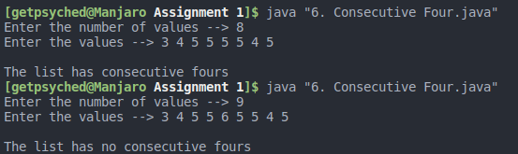

7. Remove duplicates from an array
Write a method that returns a new array by eliminating the duplicate values in the array using the following method header:
public static int[] eliminateDuplicates(int[] list)
Write a test program that reads in ten integers, invokes the method, and displays the result. Here is the sample run of the program:
Enter ten numbers: 1 2 3 2 1 6 3 4 5 2
The distinct numbers are: 1 2 3 6 4 5

import java.util.Scanner;

public class foobar {

public static void main(String[] args) {
Scanner scanner = new Scanner(System.in);

System.out.print("Enter ten numbers --> ");
int i, list[] = new int[10];
for (i=0; i<10; i++)
list[i] = scanner.nextInt();

int result[] = eliminateDuplicates(list);

System.out.print("The distinct numbers are --> ");
for (i=0; i < result.length; i++)
System.out.print(result[i] + " ");
}

public static int[] eliminateDuplicates(int[] list) {
int count = 0;
int temp[] = new int[10];

for (int i = 0; i < list.length; i++) {
boolean exists = false;
for (int j = 0; j < temp.length; j++)
if (temp[j] == list[i])
exists = true;

if (!exists)
temp[count++] = list[i];
}

int result[] = new int[count];
System.arraycopy(temp, 0, result, 0, count);
return result;
}
}
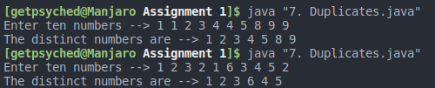

8. Check if two arrays are identical
The arrays list1 and list2 are identical if they have the same contents. Write a method that returns true if list1 and list2 are identical, using the following header:
public static boolean equals(int[] list1, int[] list2)
Write a test program that prompts the user to enter two lists of integers and displays whether the two are identical. Here are the sample runs. Note that the first number in the input indicates the number of the elements in the list. This number is not part of the list.
Enter list1: 5 2 5 6 6 1
Enter list2: 5 5 2 6 1 6
Two lists are identical
Enter list1: 5 5 5 6 6 1
Enter list2: 5 2 5 6 1 6
Two lists are not identical

import java.util.Scanner;

public class foobar {

public static void main(String[] args) {
Scanner scanner = new Scanner(System.in);

System.out.print("Enter first list --> ");
int list1[] = new int[scanner.nextInt()];
for (int i = 0; i < list1.length; i++)
list1[i] = scanner.nextInt();

System.out.print("Enter second list --> ");
int list2[] = new int[scanner.nextInt()];
for (int i = 0; i < list2.length; i++)
list2[i] = scanner.nextInt();

if (equals(list1, list2))
System.out.println("\nTwo lists are identical");
else
System.out.println("\nTwo lists are not identical");
}

public static boolean equals(int[] list1, int[] list2) {
if (list1.length != list2.length)
return false;

for (int i = 0; i < list1.length; i++) {
boolean exists = false;
for (int j = 0; j < list2.length; j++)
if (list1[i] == list2[j]) {
exists = true;
list2[j] = '\0';
break;
}

if (!exists)
return false;
}

return true;
}



